|  |  |  |  |  |  |
| --- | --- | --- | --- | --- | --- |
| Date | 12-Dec-22 | | | Tester Name | Mayuri Patel |
| Environment | Penfax - Test | | | Login used |  |
| Operating System | Select OS | Version: | Update: | | |
| Software Used | Select Software | Version: | Update: | | |
| Select Software | Version: | Update: | | |
| Release version | 22.4.1 | | | | |
| Title | E15 Reports | | | | |
| Test Type | Regression | | | | |
| Test Scenario | E15.07 Process PEPP Valuation Report | | | | |
|  |  | | | | |
| Expected Results | All 12 sections should be validated against members’ investment accounts and the fund balance summary report generated by PEPP. | | | | |
| Pass/Fail | Pass | | | JIRA# |  |

Describe your steps with screenshots:

1. Log into Penfax. Go to Batches -> Batch Processes. Select PEPP Valuation Report from the dropdown. Click on Search.

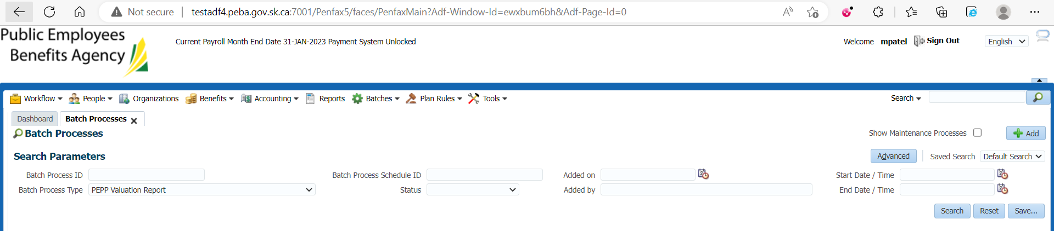

1. This batch is scheduled to run every day at 9 pm. Click on the first Batch Process ID.

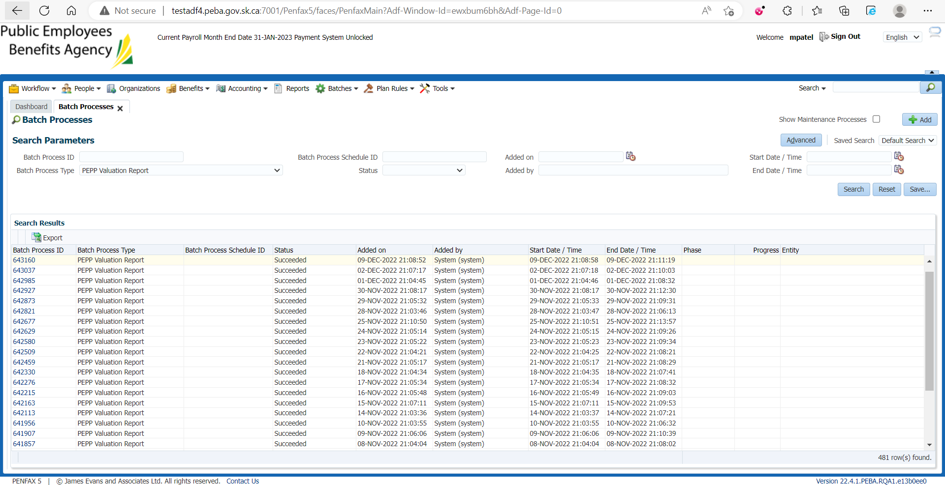

1. Go to Files tab.

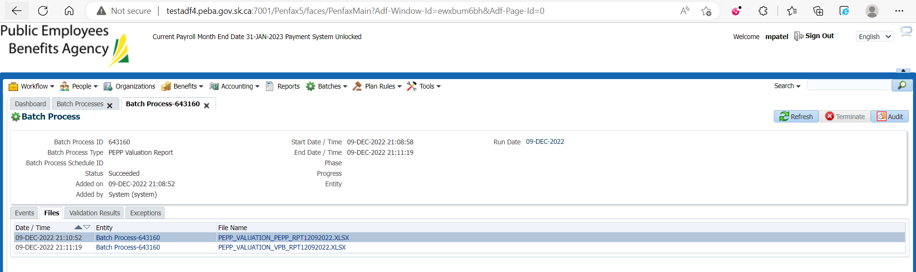

1. There are 2 separate reports – for PEPP and VPB.



1. Open the PEPP report.

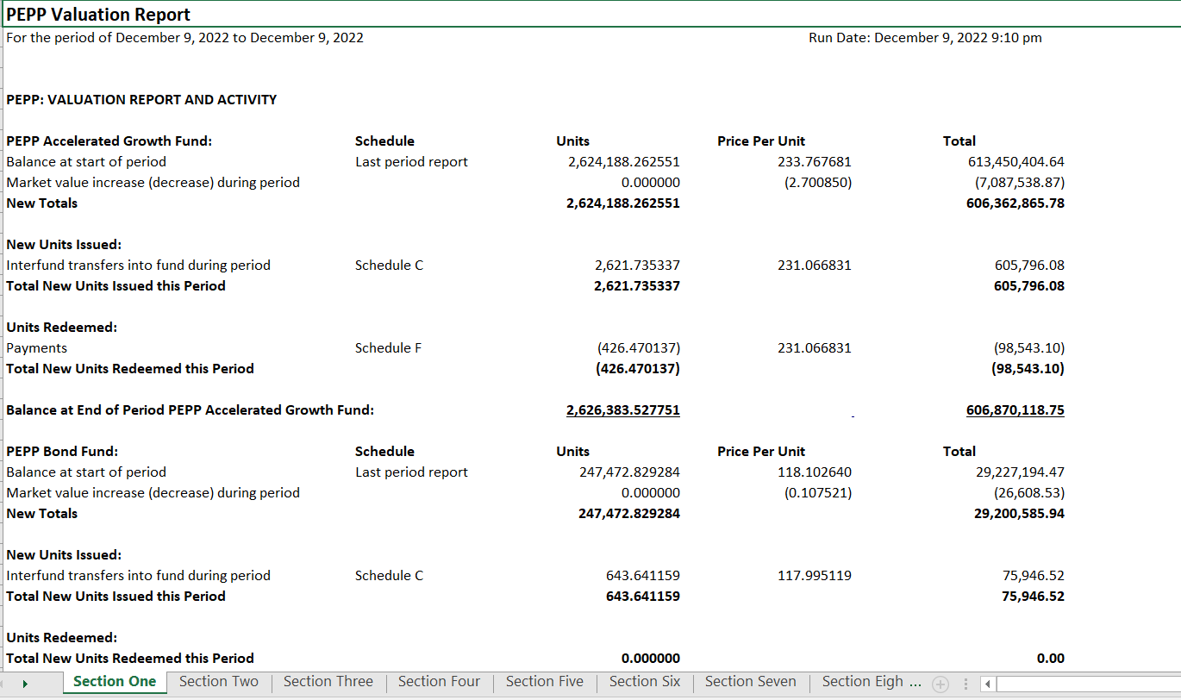

1. There are total 12 sections in this report defining different areas of investment.

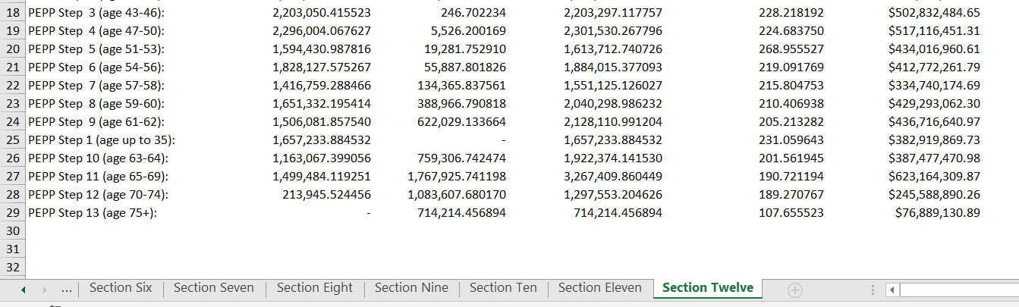

1. Section 1: Valuation Report and Activity displays the opening units and total amount, new units that were added on the previous day and the total units and amount at the end of the day (closing balance).

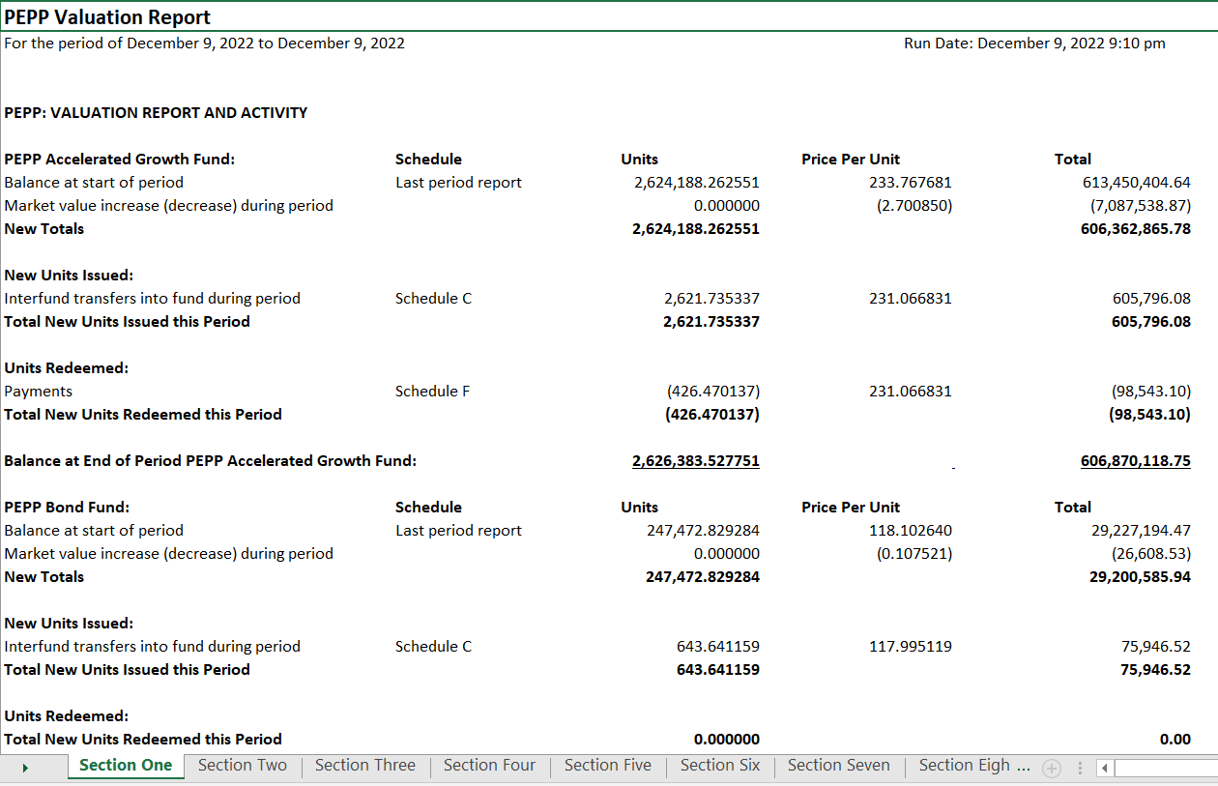

PEPP Business generates a daily report to validate PEPP Valuation Report generated by Penfax Production and saves it in H:\Pension Programs\PEPP\Reporting Projects\Penfax Reporting.

1. Section 2: Contributions Received and Allocated - Schedule A: Units Issued for Contributions Received displays the total contributions that were processed on the previous day and the employers who sent it in.

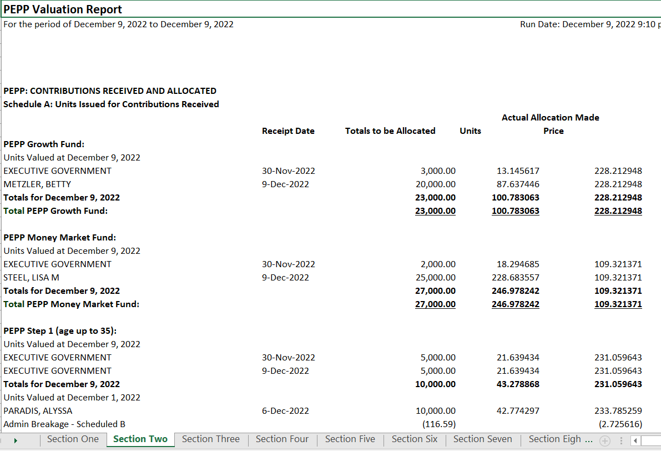

1. Section 3: Schedule B: Calculation of Breakage on Units Issued for Contributions Received but Backdated to Prior Periods displays the administrative and employer breakages fund wise that were generated with the contribution processed on the previous day.

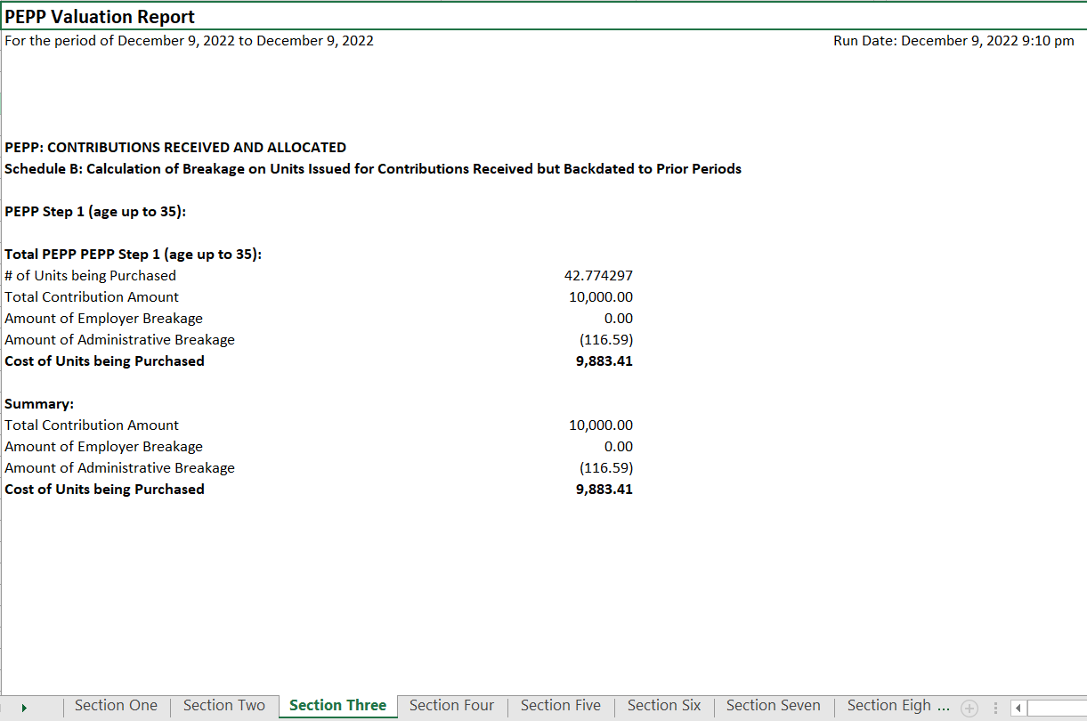

Go to Batches -> Breakage Occurrences. Search with plan and transaction date and validate the breakage amount.

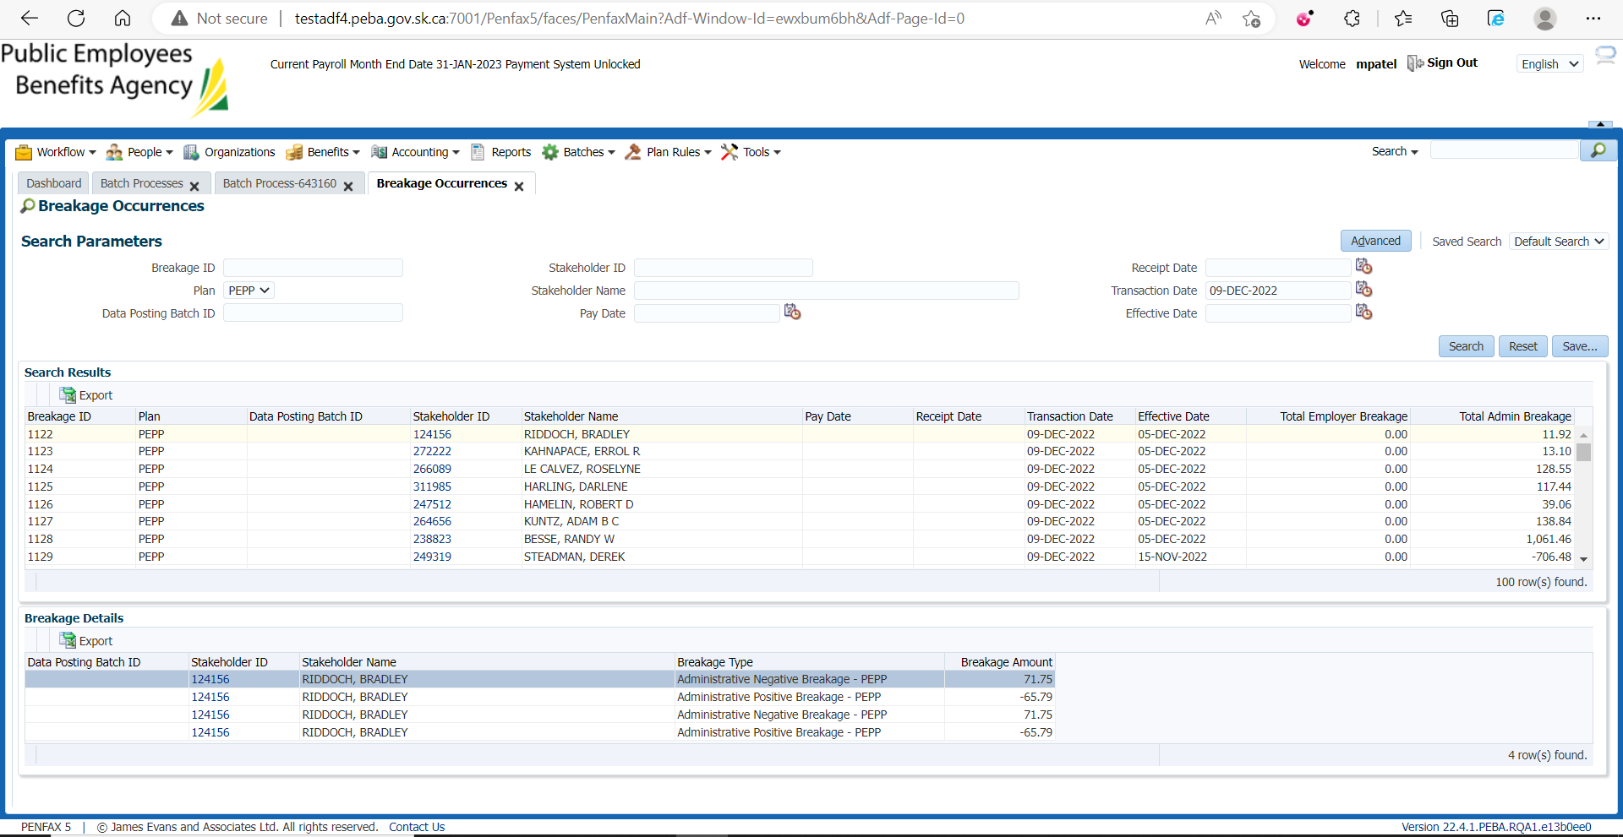

1. Section 4: Interfund Transfers In displays all the transfers that are processed in for members and funds in which the money was transferred.

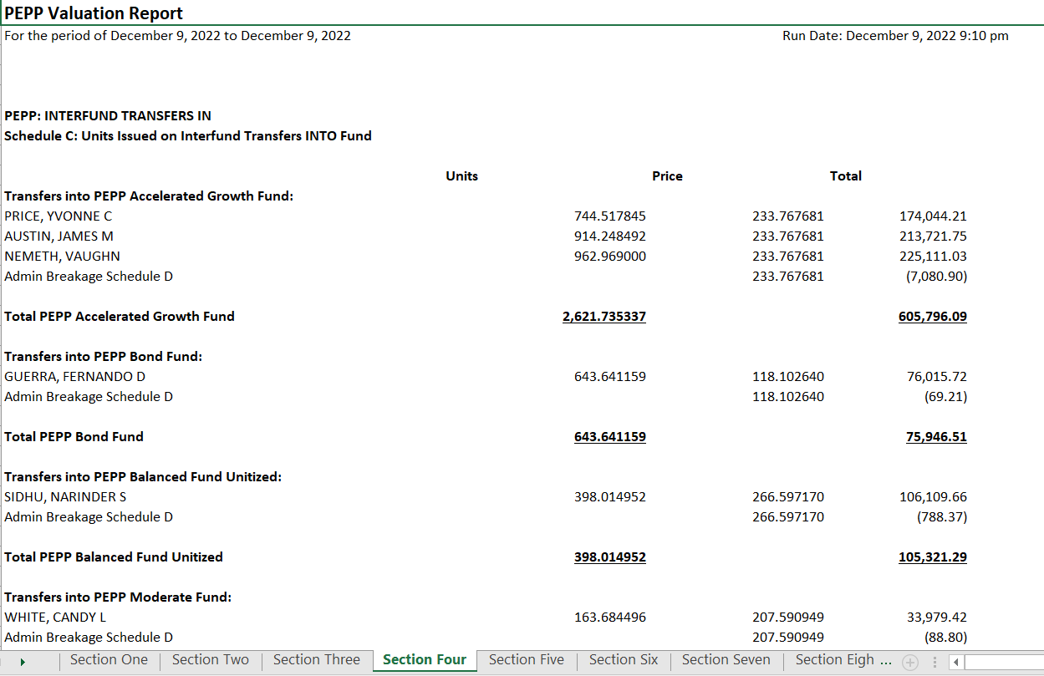

For example, bring up the 1st member. Go to Investments -> Account Activity and validate the details against PEPP Valuation Report.

1. Section 5: PEPP: INTERFUND TRANSFERS IN BACKDATED TO PRIOR PERIODS - Schedule D: Breakage Calculation on Units Issued for Interfund Transfers Backdated to Prior Periods

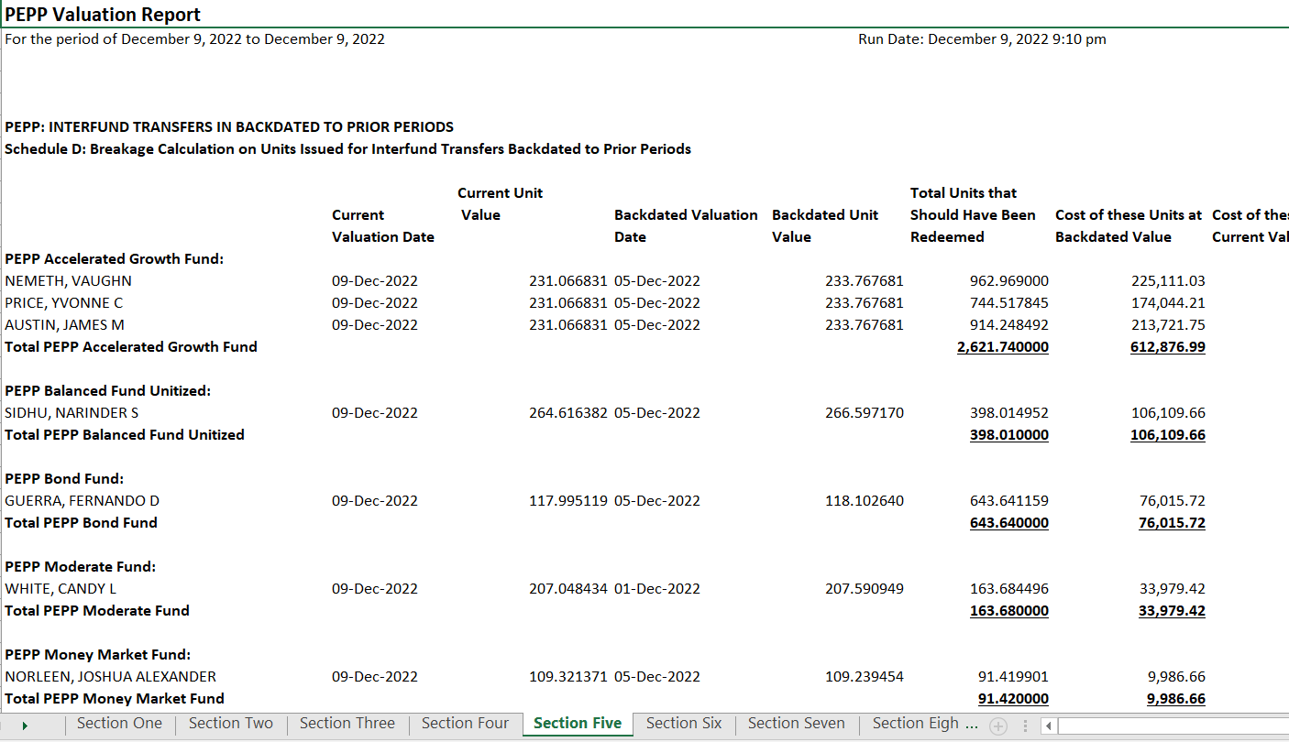

1. Section 6: ADJUSTMENTS ISSUED AND REDEEMED - Schedule E: Units Issued and Redeemed as Adjustments to Member Balances Current Valuation and Prior Valuations Breakage

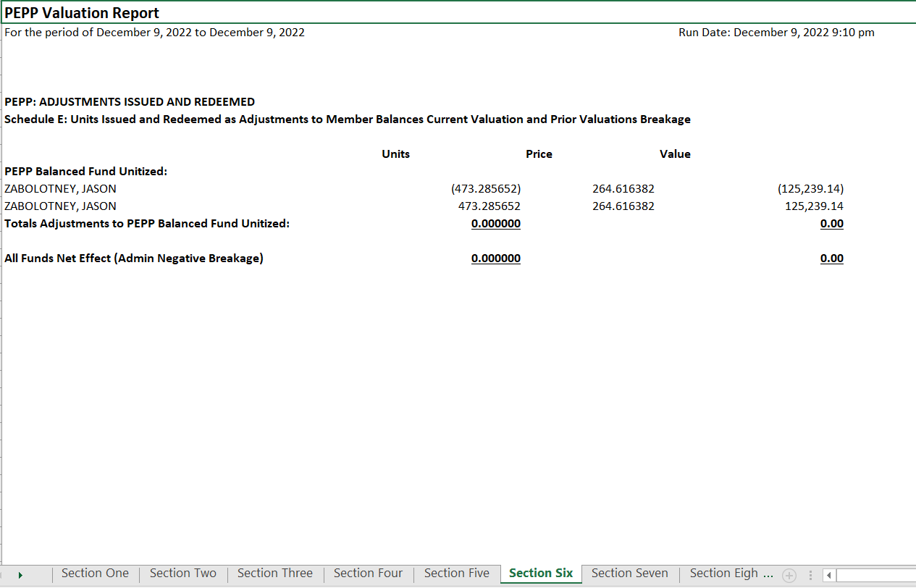

Bring up the 1st member. Go to Investment -> Account Activity and validate

Bring up the 2nd member. Go to Investment -> Account Activity and validate

1. Section 7: Payments and Refunds displays the payments that were processed on the previous day. It displays the units that were processed out and the total amount that was paid to the benefit recipient and at the end, summary of the funds in which the payment was processed into.

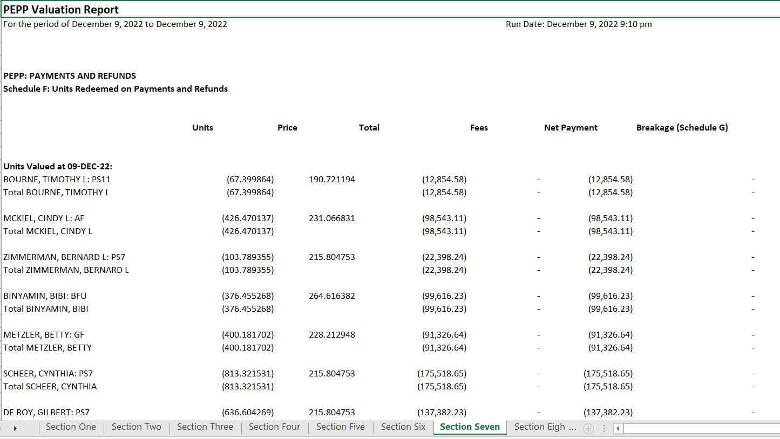

Bring up a member. Go to Investment -> Account Activity.

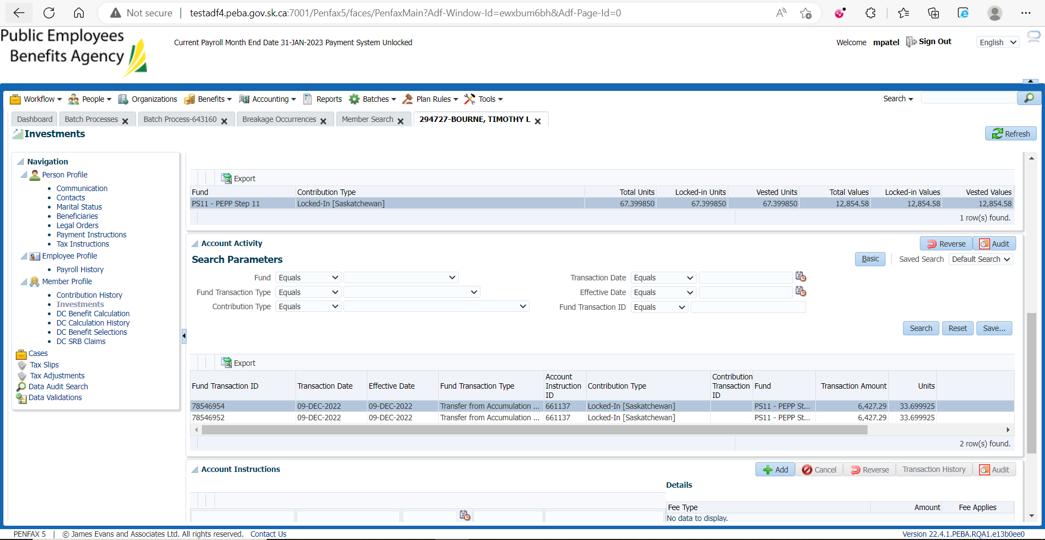

1. Section 8: PAYMENTS BACKDATED TO PRIOR PERIODS – Schedule G: Calculation of Breakage on Units Redeemed on Payments and Refunds

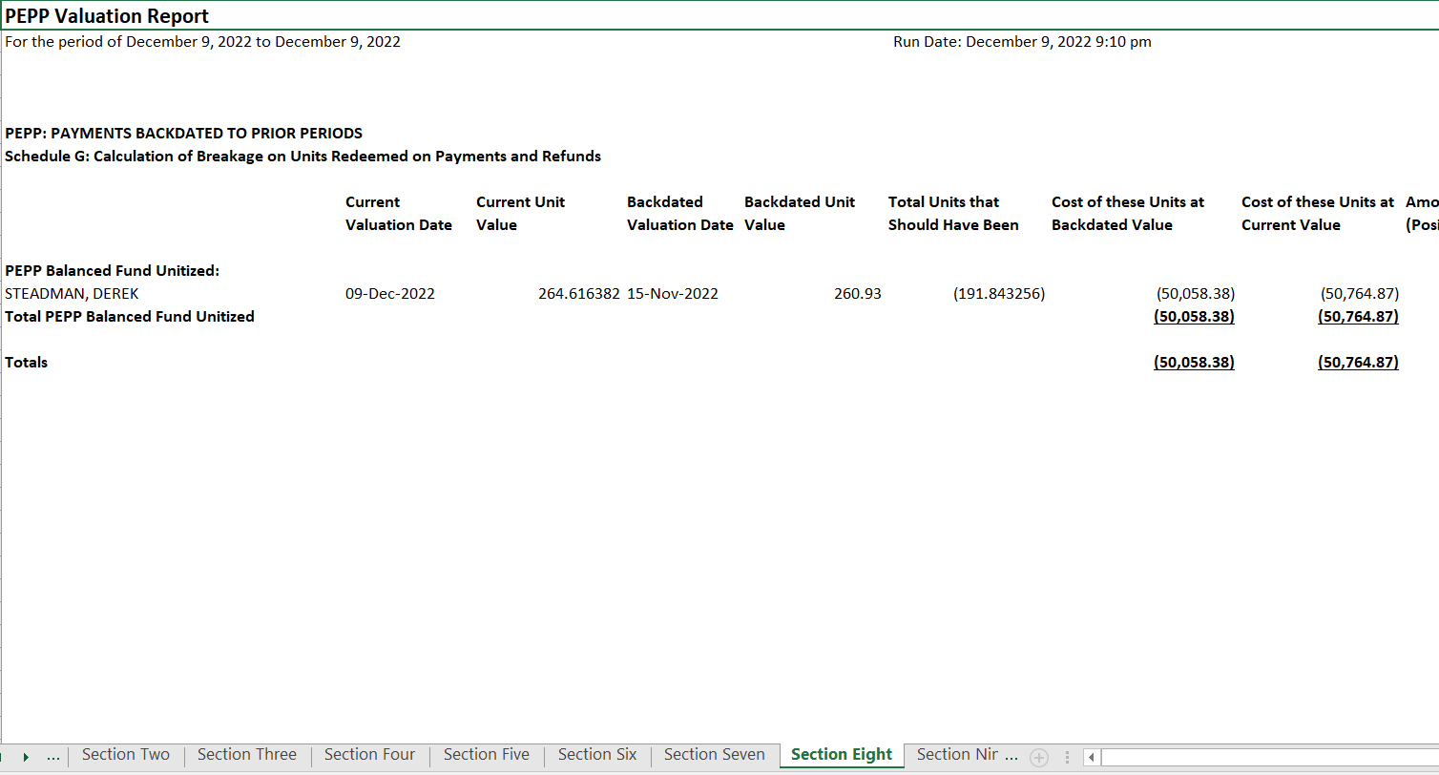

Go to Batches -> Breakage Occurrences. Search with plan and transaction date and validate the effective date and the breakage amount.

1. Section 9: Interfund Transfers Out displays all the transfers that are processed out for members and funds from which the money was transferred out.

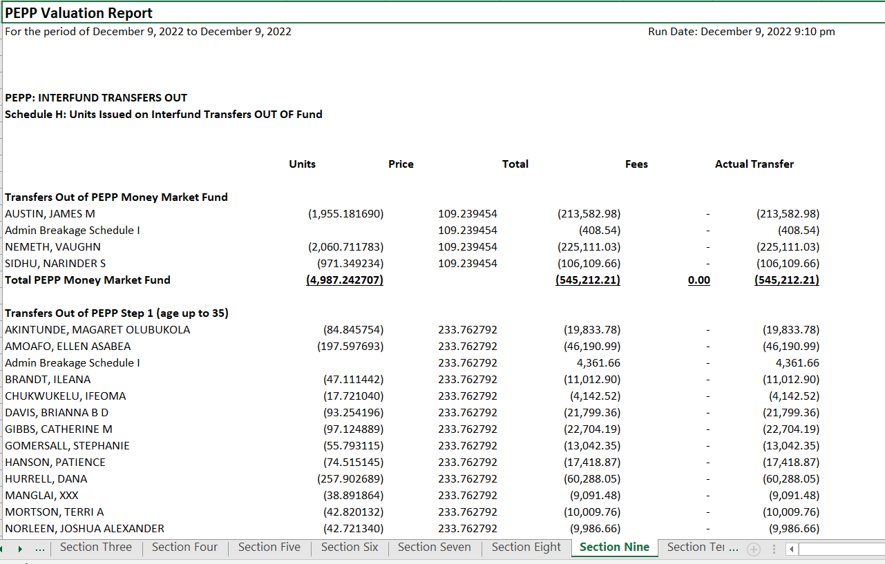

Bring up the same member that we used as an example in Section 4: Interfund Transfers In. Go to Investments -> Account Activity and validate the details against PEPP Valuation Report.

1. Section 10: INTERFUND TRANSFERS OUT BREAKAGE CALCULATION - Schedule I: Breakage Calculation on Units Redeemed for Interfund Transfers Backdated to Prior Periods

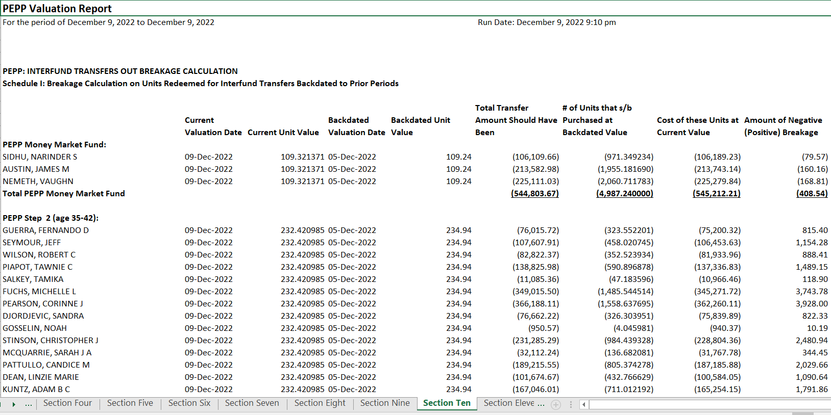

Bring up a member. Go to Investment -> Account Instruction.

Go to Batches -> Breakage Occurrences -> Search with Plana and Effective Date/Transaction Date. Administrative Positive Breakage should be validated.

1. Section 11: Valuation Report Summary displays the total units and balance for all funds in PEPP, all funds in VPB and the total of all funds in PEPP and VPB together. It also displays the summary by funds.

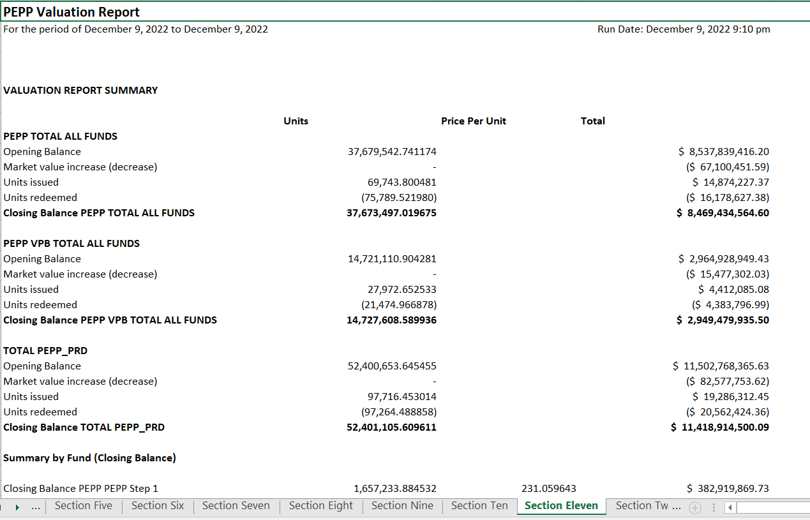

PEPP Business generates a daily report to validate PEPP Valuation Report generated by Penfax Production and saves it in H:\Pension Programs\PEPP\Reporting Projects\Penfax Reporting.

1. Section 12: Daily Summary of the PEPP Valuation Report displays the summary of funds – PEPP and VPB units along with Unit Values and Total Dollar Amount.

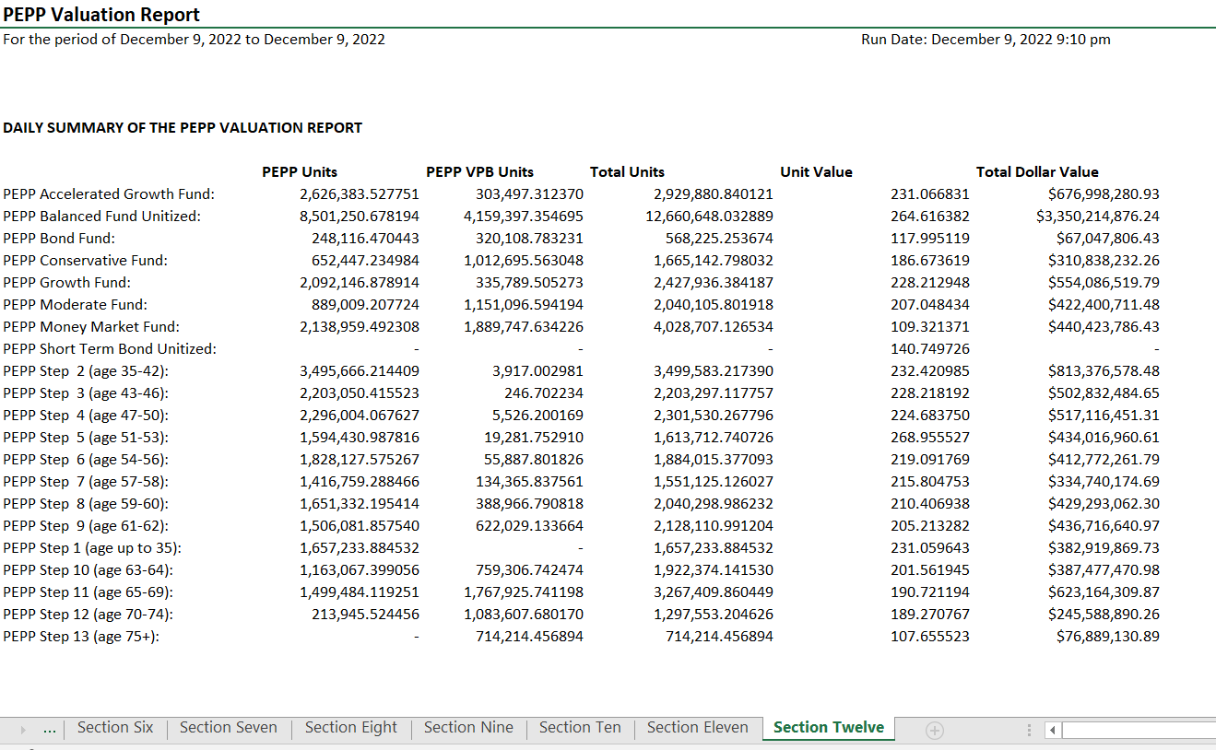

PEPP Business generates a daily report to validate PEPP Valuation Report generated by Penfax Production and saves it in H:\Pension Programs\PEPP\Reporting Projects\Penfax Reporting.

As this is the test region, Section 12 can be validated against Capstock Report. For this, go to Batches -> Batch Processes -> select Process Investment Transactions and open the batch process of the same date as of Valuation Report.

Go to Files tab and open the CSV file.

Verify the PEPP and VPB units along with Unit Values and Total Dollar Amount.

1. To validate VPB Valuation Report, follow step 5 to 12.